

**Port of Monroe gets $3 million loan for improvements**

By Danielle Portteus As of Friday, September 25, 2015, 02:30 p.m.

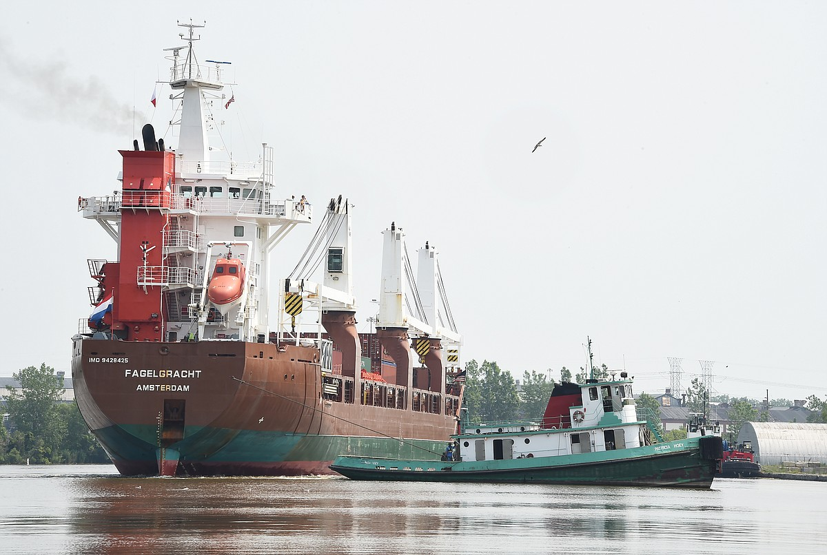

The tug boat Patricia Hoey of Gaelic Tug Boat Company from Detroit turns the Fagelgracht of Amsterdam in the Port of Monroe to unload gas lines after crews unloaded blades for Ventower's wind turbine towers. (Monroe News photo by TOM HAWLEY)

A major infrastructure project at the Port of Monroe could change the landscape of the local economy while promoting similar port projects throughout the state. On Tuesday, the Michigan Strategic Fund approved up to a $3 million loan from its investment funds to improve the port, the Michigan Economic Development Corporation announced. “Inevitably, this will lead to sustainable economic impact in Southeast Michigan and the City of Monroe,” said Paul C. LaMarre III, port director. The money will be used to create two large, cellular cofferdams along Lake Erie, allowing ships to be moored against the Port of Monroe. The deal, the first on the Great Lakes, has been in the works for three years and led by Mr. LaMarre, who has been advocating actively for improvements to ports in the state. “I see it as my duty to advocate for all American ports. We will succeed or fail as a Great Lakes port system,” he said. “The investment here will benefit other ports in Michigan.” The Port of Monroe has seen great success since Mr. LaMarre came on board three years ago. This agreement is his latest. Dan Swallow, director of economic and community development for the city, said the loan is unique. “This is a pilot project for the state since the MEDC hasn’t done a port-related project before,” Mr. Swallow said. Beginning next spring after fish spawning, the Port of Monroe will be dredged and about 25,000 to 30,000 cubic tons of material will be removed from the River Raisin near the port to create the cofferdams. The project expands trade routes and cargo opportunities and a range of other improvements to increase accessibility to the port, officials said. The impact is expected to cause fewer cargo delays and accommodate larger vessels with increased shipping capacity. The dramatic improvements in shipping efficiency is expected to generate a major economic impact to the Monroe region. “These improvements will transform the Port of Monroe into a center of economic activity and a premier general cargo handling facility on the Great Lakes,” said Steve Arwood, chief executive officer of the MEDC in a news release. “The project will promote further growth and investment in the Port and the region, and will lead to new jobs for Michigan residents.” advertisement Mr. LaMarre said currently the only dock available to load and unload cargo is the turning basin, which is 18 feet. With the summer rains, the water has been running about 3 feet higher, allowing for a depth of 21 feet. The dredging project will allow load vessels at a minimum draft of 21 feet. “If the water is running 3 feet high, that puts us at 24 feet, which is much closer to the St. Lawrence Seaway draft of 26.6 feet,” he said. Mr. Swallow called the area along the port “critical” for not only the current businesses along the river but to potential developers or businesses. “There is opportunity to grow the investment base there,” Mr. Swallow said. In addition to the money from the state’s strategic fund, the city approved a Brownfield Redevelopment Authority plan for the approval of $3,643,225 in local and school tax capture for brownfield-related activities to the project. The tax income revenue captured as a result of the approved brownfield plan will be used to repay the investment fund within eight years. Mr. Swallow said the money coming to the Port is essentially a loan, which will be paid back through taxes captured from the brownfield plan. “This is a way in a challenging economy when state funding is difficult to come by to move a project forward,” Mr. LaMarre said. “Instead of waiting eight years to capture the money, we are able to capture the money and capitalize on the current momentum of the port.” Michigan has 36 ports but no infrastructure program in place to care for them. Mr. LaMarre thanked Gov. Rick Snyder and Mr. Arwood for moving this project forward. “Our waterways or docks are in as bad or worse shape than our roads,” Mr. LaMarre explained. “Think of the waterways as our first and last point of entry in our state. It is critically important to reinvest in the infrastructure of our ports which were created during war-time.” The dredging is expected to be completed during the latter half of the 2016 shipping seaso  
  
Read more at: <http://www.monroenews.com/news/2015/sep/25/port-monroe-gets-3-million-loan-improvements/>